Causes of death in Taiwan, 2012
All causes of death are based on the Underlying Cause of Death and are processed in accordance with the International Classification of Diseases. Causes of death were coded and classified according to the Ninth Revision (ICD-9) during 1969-2006, and according to the Tenth Revision (ICD-10) after 2007. The standardized mortality rate (age-adjusted death rate) is age-standardized to the WHO 2000 global standard population.
- The standardized mortality rate declined and life expectancy at birth increased in 2012.
In 2012, a total of 153,823 deaths were reported in Taiwan. The standardized mortality rate was 450.6 deaths per 100,000 population, which was 2.5% lower than the 2011 rate and 19.3% lower than the 2001 rate.
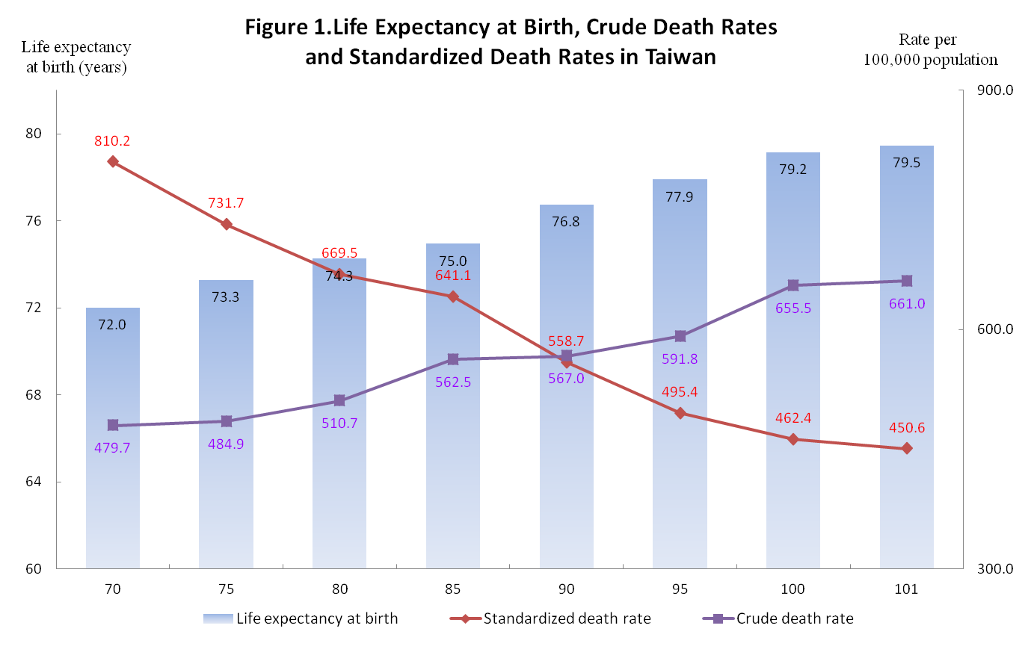
According to Ministry of the Interior’s preliminary statistics, life expectancy at birth in 2012 is 79.5 years for total population(0.3 year higher than the 2011), continuing a long-term rising trend. Life expectancy for males increased 0.2 year from 2011 to 76.2 years in 2012, and life expectancy for females increased 0.4 year from 2011 to 83.0 years in 2012.
The National Health Insurance (NHI) has been implemented since 1995 and it improves Taiwanese’s access to medical resources. In conclusion, NHI leads to Taiwanese’s longer life span and lower standardized mortality rate.
- Decedents aged 65 years and over accounted for 68.8% of total deaths in 2012.
In 2012, people aged 65 years and over accounted for 11.0% of total population, which is 2.3 percentage points higher than the figure in 2001.
Owing to the aging of the population, percentage of decedents aged 65 and over of total deaths continued its upward trend in 2012. The percentage was 46.8% in 1981, 61.0% in 1996 and 68.8% in 2012.
In 2012, the percent of total deaths by age group is:
0-64 years (31.2% of total deaths)
65-74 years (16.7% of total deaths)
75-84 years (29.0% of total deaths)
85 years and over (23.2% of total deaths)
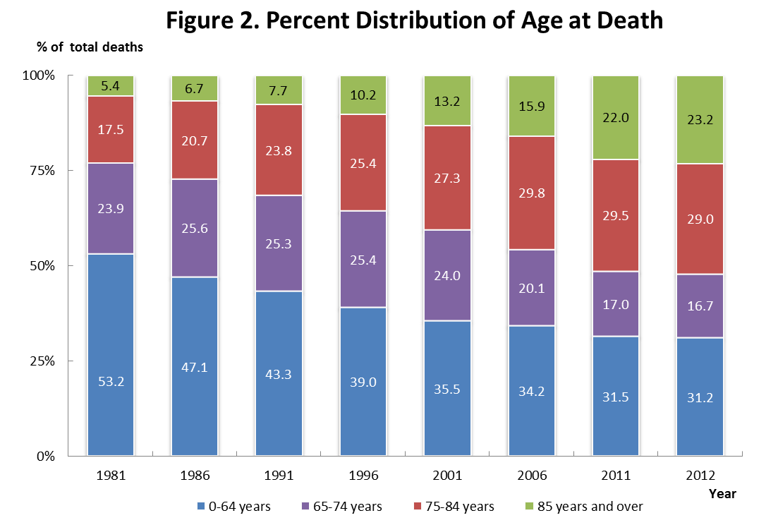
Decedents aged 85 years and over experienced the significant increase of 10 percentage points, of which 8.5 and 1.5 percentages points were accounted for the age group 85-94 and 95+ respectively, compared with 2001. The figures show deaths aged elder constituted more of total deaths.
- Malignant neoplasm continued to be the most deadly cause.
The 10 leading cause of death and its percentage of total deaths in 2012 were as follows:
(1) Malignant neoplasms--28.4%
(2) Diseases of heart (except hypertensive diseases)--11.1%
(3) Cerebrovascular diseases--7.2%
(4) Pneumonia--6.1%
(5) Diabetes mellitus--6%
(6) Accidents and adverse effects--4.5%
(7) Chronic lower respiratory diseases--4.1%
(8) Hypertensive diseases--3.2%
(9) Chronic liver disease and cirrhosis--3.2%
(10) Nephritis, nephrotic syndrome and nephrosis--2.8%
Most of the 10 leading causes of death were chronic diseases, and malignant neoplasms, whose percent of total deaths was further higher than other leading causes, has been the 1st cause of death for consecutive 31 years.
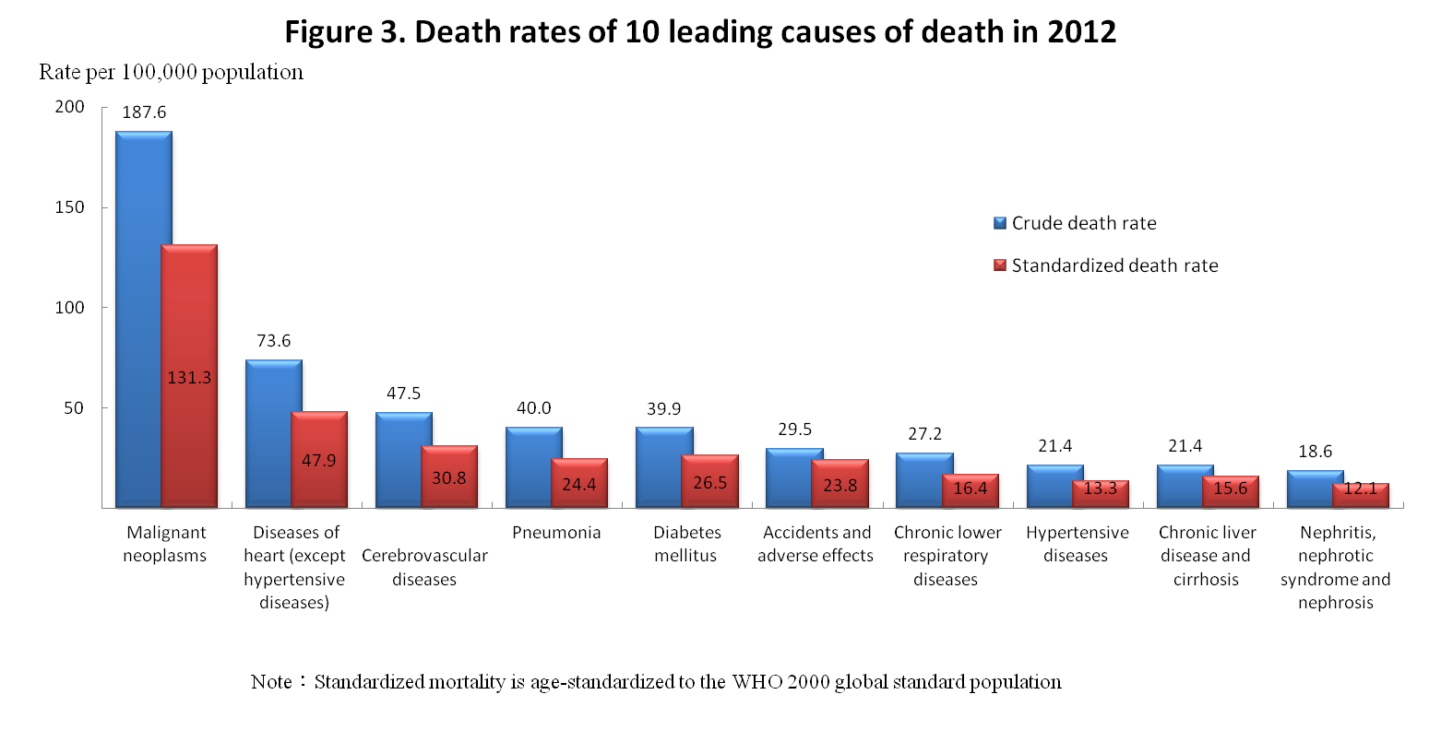
Causes of death are ranked according to the crude death rate. In 2012, six of the ten leading causes remained the same as in 2011. Pneumonia, the 5th cause in 2011, exchanged with diabetes mellitus, the 4th cause in 2011, became the 4th cause in 2012. Hypertensive diseases, the 9th cause in 2011, exchanged with chronic liver diseases and cirrhosis, the 8th cause in 2011, became the 8th cause in 2012.
Compared the ranking in 2012 with the one in 2001, hypertensive diseases and pneumonia rose its rank while accidents and adverse effects, cerebrovascular diseases, chronic liver disease and cirrhosis , and nephritis, nephrotic syndrome and nephrosis fell down. Intentional self-harm(suicide), replaced by chronic lower respiratory diseases , dropped from among 10 major causes,
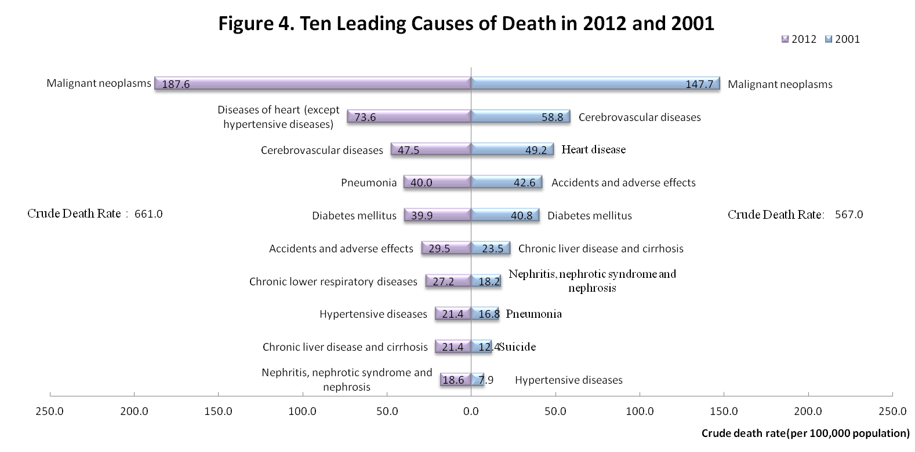
Compared with 2001, two major causes, hypertensive diseases and pneumonia, showed increases in standardized mortality and percent of total deaths in 2012 while 5 causes in quadrant III shown in figure 5 decreased. Malignant neoplasms, diseases of heart, and chronic lower respiratory diseases increased in percent of total deaths but decreased in standardized mortality rate.
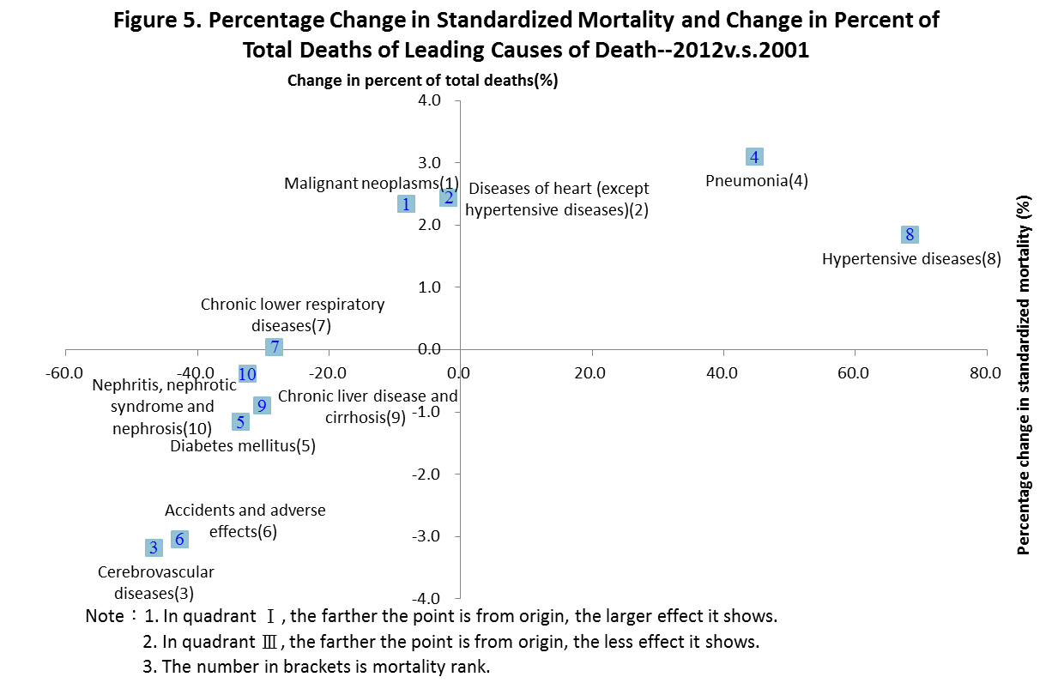
- Median age at death was 4 years longer in 2012 than the age in 2001.
The average age at death was 70.9 years in 2012, a 0.3 year higher than the 2011 age, and 4.6 years higher than the 2001 age. The median age at death was 75.0 years in 2012, a 4.0-year rise compared with 2001.
Of the ten leading causes, 7 causes, shown in Table 1, have higher median age at death than the overall median age at death, 75.0 years, most of which were chronic diseases.
All of the ten leading causes showed a upward trend in median age at death, except chronic diseases and cirrhosis. Accidents and adverse effects increased significantly by 11 years during 2001 to 2012.
- The standardized mortality rate for males decreased by 16% compared with 2001.
In 2012, males had higher number of deaths, crude death rate, and standardized death rate than females, by 1.5~1.7 times.
The number of deaths for males was 93,197. The standardized mortality was 573.1 deaths per 100,000 population, which was a fall of 3.0% from 2011, and a fall of 15.6% from 2001.
In 2012, eight of the ten leading causes for males remained the same as in 2011. Chronic respiratory diseases, the 7th causes in 2011, exchanged with diabetes mellitus, the 6th cause in 2011, became the 6th cause in 2012.
The 10 leading cause of death for males and its percent of total deaths in 2012 were as follows:
(1) Malignant neoplasms--29.3%
(2) Diseases of heart (except hypertensive diseases)--11%
(3) Cerebrovascular diseases--6.9%
(4) Pneumonia--6.2%
(5) Accidents and adverse effects--5.3%
(6) Chronic lower respiratory diseases--5%
(7) Diabetes mellitus--4.9%
(8) Chronic liver disease and cirrhosis--3.8%
(9) Hypertensive diseases--2.7%
(10) Intentional self-harm (suicide)--2.6%
As shown in Figure 6, four causes of the ten leading cause for males increased in standardized death rate (in quadrant I and IV), including hypertensive diseases, diseases of heart, pneumonia, and intentional self-harm (suicide), while others decreased (in quadrant II and III).
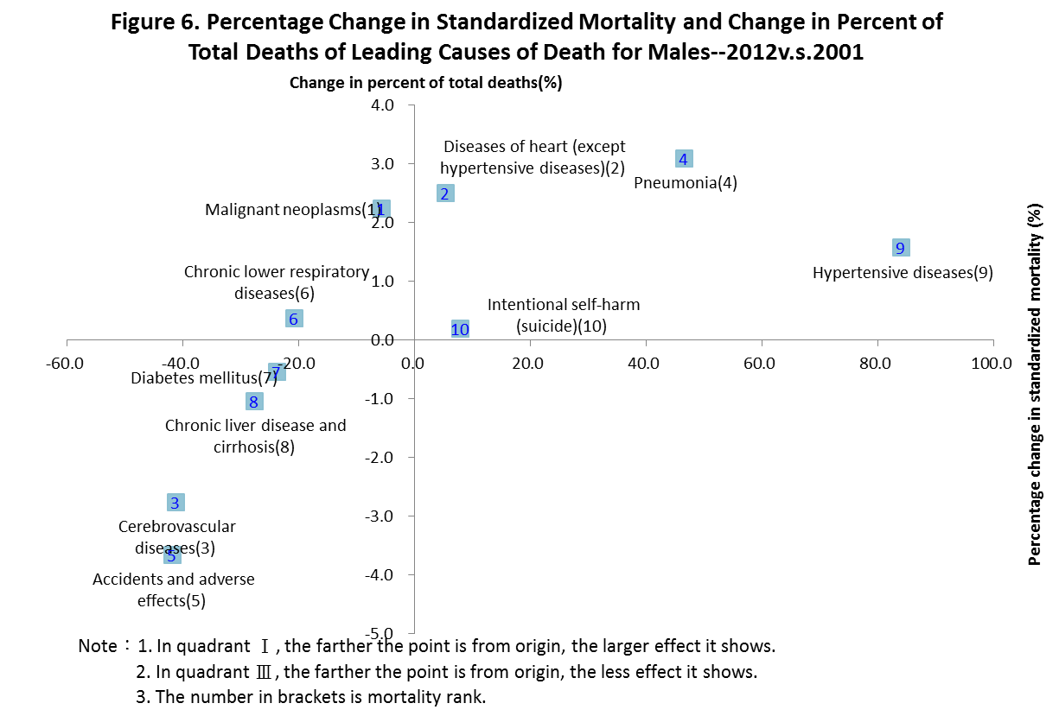
- The standardized mortality rate for females decreased by 23% compared with 2001.
In 2012, the number of deaths for females was 60,626. The standardized mortality was 335.4 deaths per 100,000 population, which was a fall of 1.5% from 2011, and a fall of 22.6% from 2001.
In 2012, eight of the ten leading causes for females remained the same as in 2011. Chronic lower respiratory diseases, the 10th causes in 2011, exchanged with septicemia, the 9th cause in 2011, became the 9th cause in 2012.
The 10 leading cause of death for females and its percentage of total deaths in 2012 were as follows:
(1) Malignant neoplasms--27%
(2) Diseases of heart (except hypertensive diseases)--11.3%
(3) Diabetes mellitus--7.7%
(4) Cerebrovascular diseases--7.6%
(5) Pneumonia--5.9%
(6) Hypertensive diseases--4.1%
(7) Nephritis, nephrotic syndrome and nephrosis--3.4%
(8) Accidents and adverse effects--3.2%
(9) Chronic lower respiratory diseases--2.7%
(10) Septicemia--2.5%
As shown in Figure 7, three causes of the ten leading cause for females increased in standardized death rate (in quadrant I and IV), including hypertensive diseases , septicemia and pneumonia, while others decreased (in quadrant II and III).
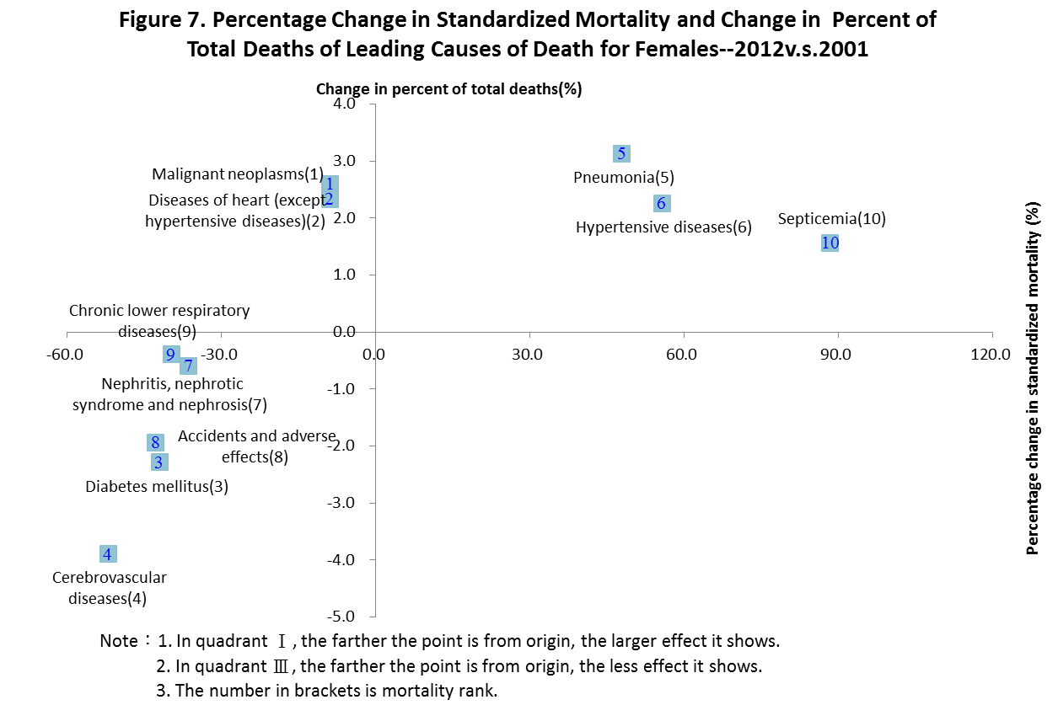
- Infant mortality rate was 3.7 ‰ in 2012, a 39.4% decrease from 2001.
A consistent downward trend was observed in infant mortality rate and neonatal mortality rate.
In 2012, there were 860 infant deaths (under 1 year of age) registered, giving a rate of 3.7 per 1,000 live births. The infant death rate decreased 2.4 deaths per 1,000 live births or by 39.4% from 2001 to 2012. The infant death rate for males was 4.0 per 1,000 live births, slightly higher than the rate for females, 3.3 per 1,000 live births.
There were 538 deaths of infants aged 0-27 days in 2012, give a neonatal mortality rate of 62.6 per 1,000 live births. The rate decreased 1.1 deaths per 1,000 live births or by 31.6 from 2001 to 2012.
The maternal mortality rate was 8.5 deaths per 100,000 live birth, a 22.1% higher than the rate in 2001.

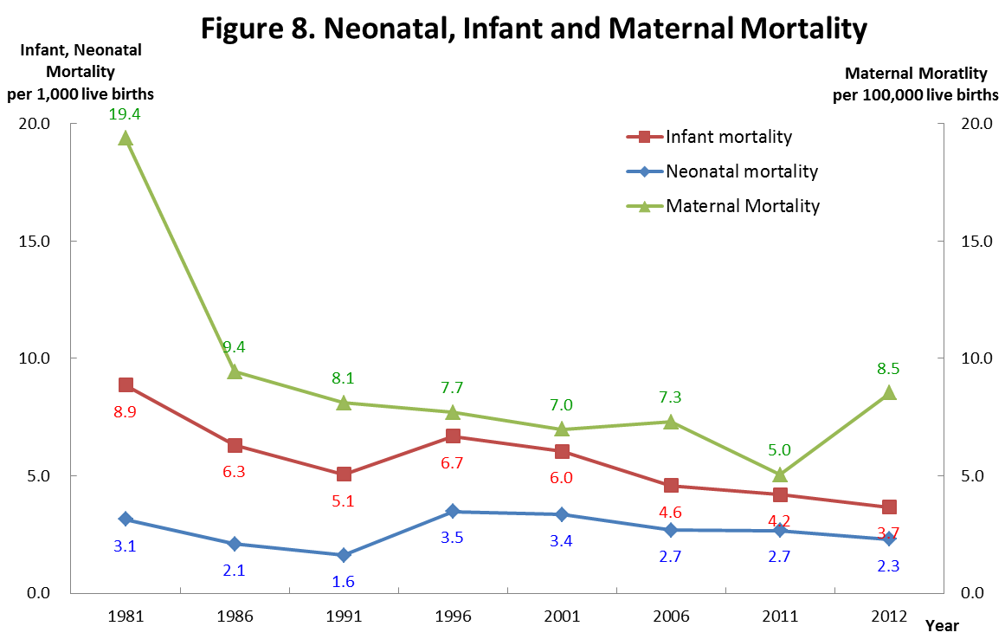
The 5 leading causes of death for infant were responsible for 54.4% of total infant deaths. The causes and its percent of total infant deaths were as follows:
(1) Diseases of the skin and subcutaneous tissue--22.6%
(2) Accidental falls--15.8%
(3) Accidental poisoning--6%
(4) Accidents and adverse effects--5.1%
(5) Accidental drowning and submersion --4.9%
Compared with 2008, as shown in Figure 9, 2 of 10 leading causes for infants increased both in its crude death rate and percent of total infant deaths (in quadrant I), including Infections specific to the perinatal period and Sudden infant death syndrome. On the contrary, 3 of 10 causes decreased both in its crude death rate and percent of total infant deaths (in quadrant III), including respiratory disorders originating in the perinatal period, accidents and adverse effects and pneumonia, while the rate for pneumonia decreased the most by 48.2%.

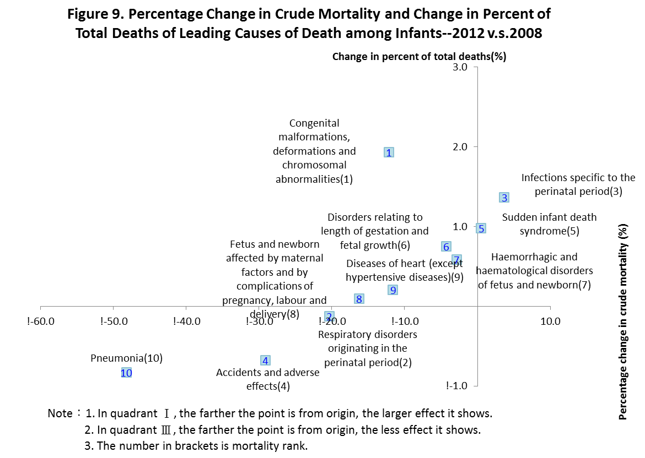
- Accidents and adverse effects was still the most common cause for decedents aged 1-14.
There were 562 deaths aged 1-14 in 2012, giving a crude rate of 17.3 per 100,000 population. which was a 4 deaths lower per 100,000 population or 3.5% lower than the rate of 2001.
Except Typhoon Morakot in 2009, the crude rate for the age group 1-14 continued its long-term decreasing trend, which was 75.2% lower than the rate of 1981 and 33.9% lower than the rate of 2001.
The 4 leading causes of death for those aged 1-14 were responsible for 54.4% of total deaths. The causes and its percent of total deaths were as follows:
(1) Accidents and adverse effects--23.1%
(2) Malignant neoplasms--18.1%
(3) Congenital malformations, deformations and chromosomal abnormalities--8.4%
(4) Diseases of heart (except hypertensive diseases)--4.8%
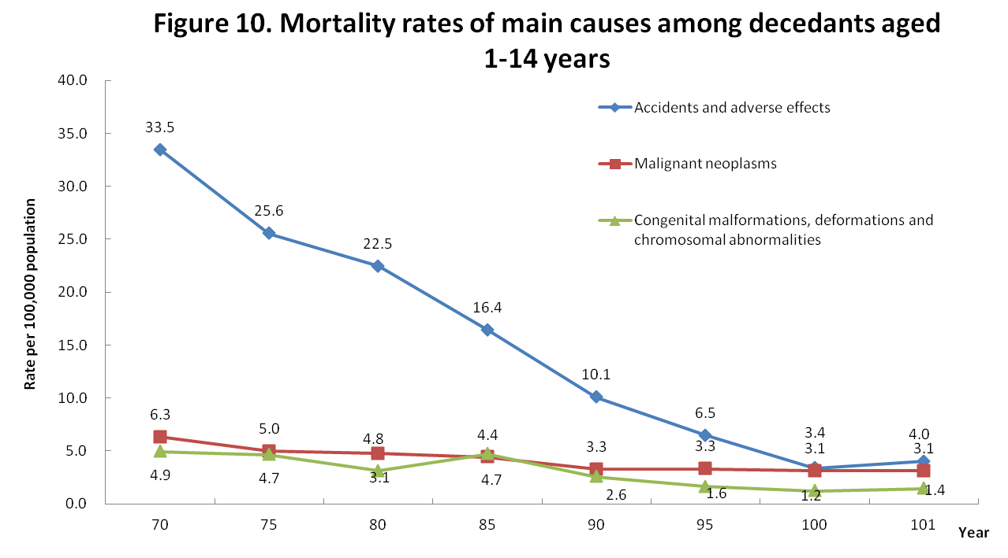
Compared with 2001, as shown in Figure 10, 5 of 10 leading cause for those aged 1-14 increased in its crude death rate (shown in quadrant I), of which Diseases of the musculoskeletal system and connective tissue, intentional self-harm, and assault (homicide) increased significantly by 261.7%, 35.6% and 35.6% respectively. Over the same period, accidents and adverse effects decreased in its crude rate the most by 60.1%, and its percent of deaths by 15.4%.
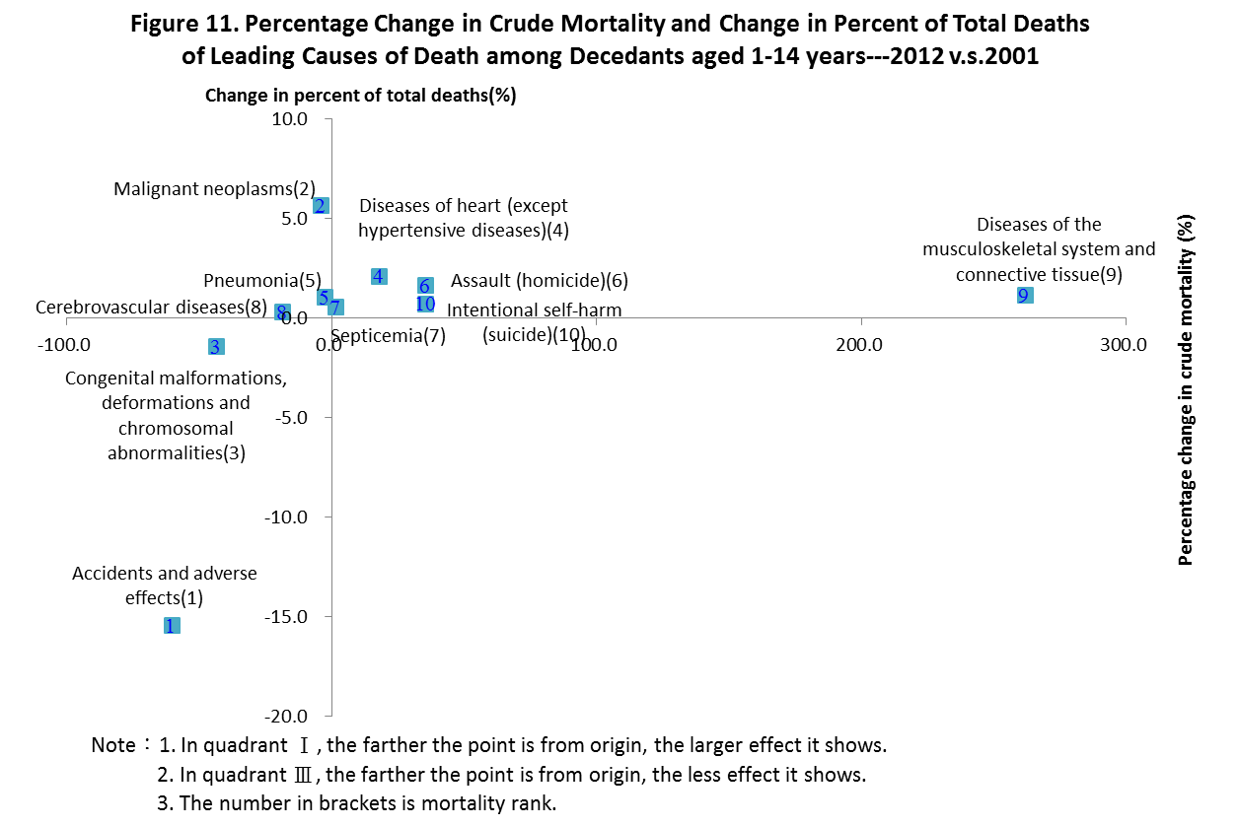
- Accidents and adverse effects and intentional self-harm (suicide) were the 2 most common for those aged 15-24, combined accounting for 60%.
There were 1,340 deaths aged 15-24 in 2012, giving a crude rate of 41.6 per 100,000 population. In long term, death rates for those aged 15-24 declined consistently by 61.2% from 1981 to 2012 or 36.7% from 2001 to 2012.
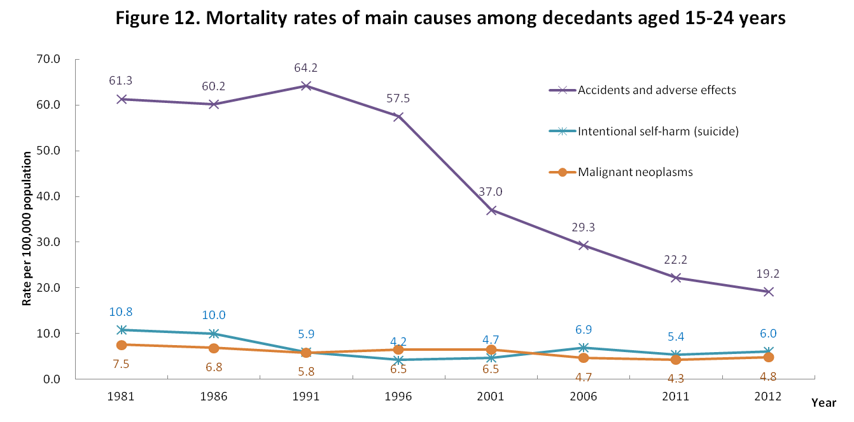
The 3 leading causes of death for those aged 15-24 were responsible for 46.1% of total deaths. The causes and its percent of total deaths were as follows:
(1) Accidents and adverse effects--46.1%
(2) Intentional self-harm (suicide) -- 14.6%
(3) Malignant neoplasms -- 11.6%
Compared with 2001, as shown in Figure 13, 5 of 10 leading cause for those aged 15-24 increased in its crude death rate (shown in quadrant I), of which the rate HIV increased the most significantly by more than 700% and the percent of total deaths for intentional self-harm increased the most by 7.4 percent. Over the same period, accidents and adverse effects and assault (homicide) decreased both in crude death rate and percent of total deaths (shown in quadrant III).
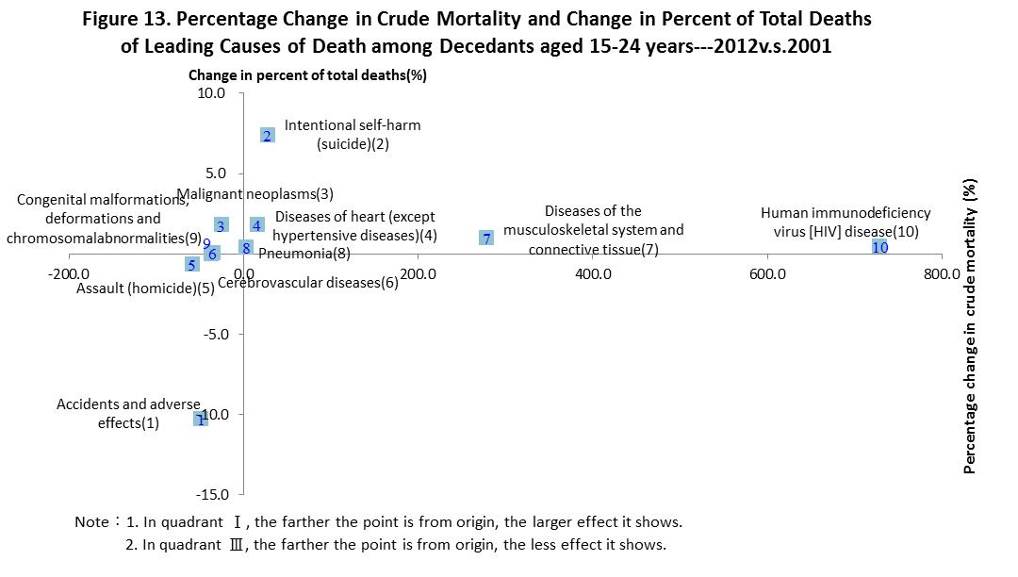
- Malignant neoplasms was the No.1 killer for those aged 25-44.
There were 9,898 deaths aged 25-44 in 2012, giving a crude rate of 132.6 per 100,000 population. The death rate decreased by 2.0% compared the rate of 2001.
The 5 leading causes of death for those aged 25-44 were responsible for 68% of total deaths. The causes and its percent of total deaths were as follows:
(1) Malignant neoplasms--24.8%
(2) Intentional self-harm (suicide)--13.9%
(3) Accidents and adverse effects--13.6%
(4) Chronic liver disease and cirrhosis--9.1%
(5) Diseases of heart (except hypertensive diseases)--7.2%

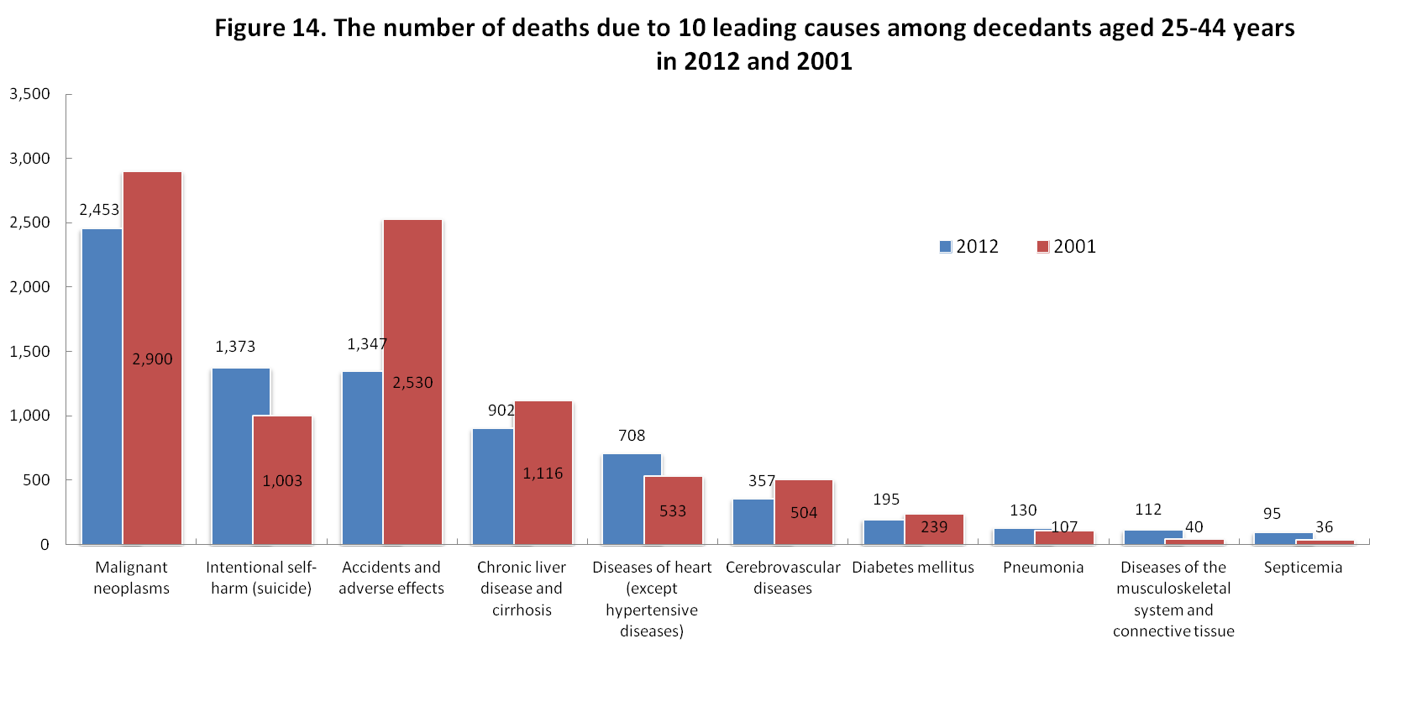
Compared with 2001, as shown in Figure 15, 5 of 10 leading cause for those aged 25-44 increased in its crude death rate (shown in quadrant I) while others decreased (shown in quadrant II and III). Accidents and adverse effects had the significant decrease in crude death rate by 46.7%.
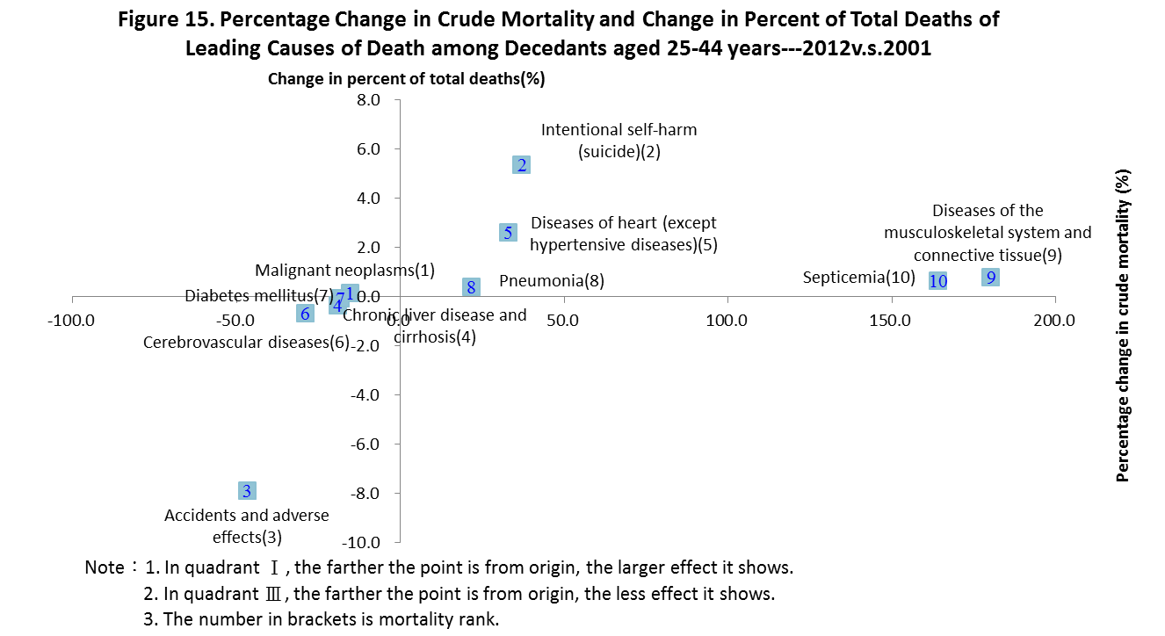
- Malignant neoplasms was the No.1 killer for those aged 45-64.
There were 35,256 deaths aged 45-64 in 2012, giving a crude rate of 537.3 per 100,000 population. The death rate decreased by 1.5% compared the rate of 2001.
The 5 leading causes of death for those aged 45-64 were responsible for 42.4% of total deaths. The causes and its percent of total deaths were as follows:
(1) Malignant neoplasms--42.4%
(2) Diseases of heart (except hypertensive diseases)--9%
(3) Chronic liver disease and cirrhosis--6.1%
(4) Accidents and adverse effects--6%
(5) Cerebrovascular diseases--5.5%
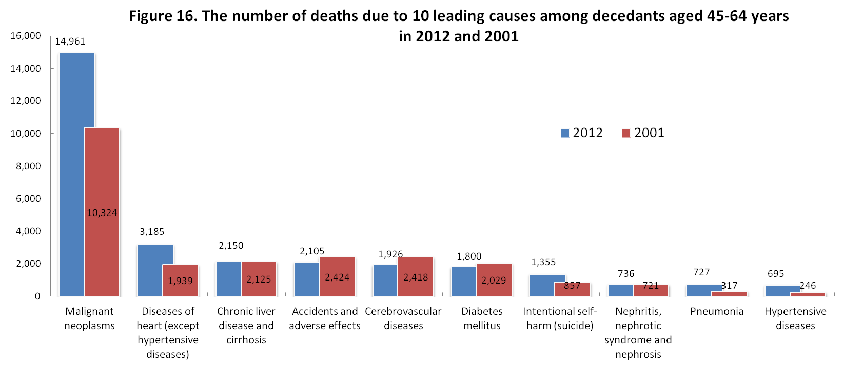
Compared with 2001, as shown in Figure 15, 4 of 10 leading cause for those aged 45-64 increased in crude death rate and percent of total deaths (shown in quadrant I) while 5 causes decreased both in crude death rate and percent of total deaths (shown in quadrant III) including accidents and adverse effects, cerebrovascular diseases and diabetes mellitus which showed less effect.
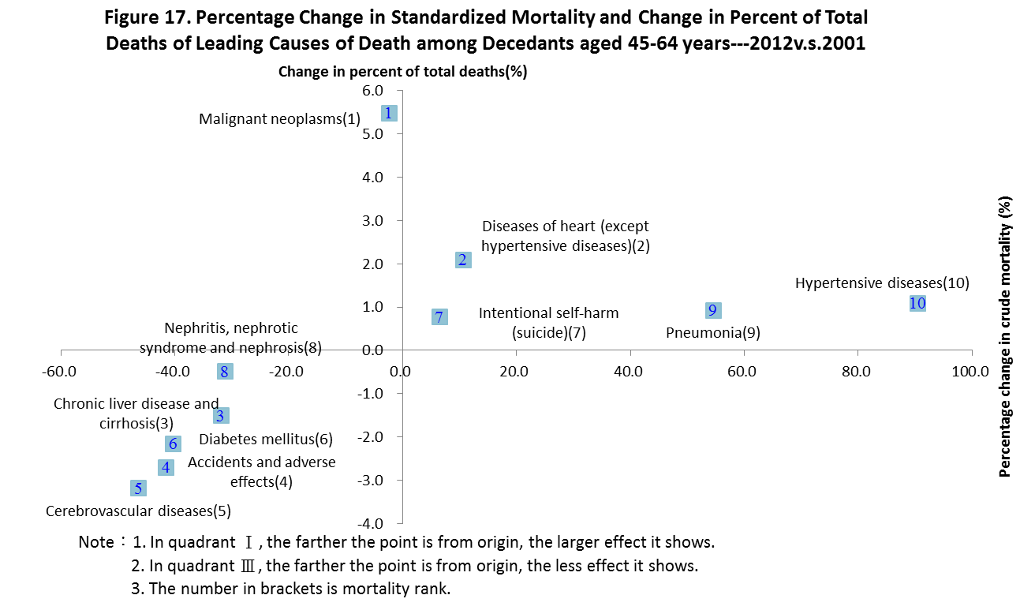
- The crude death rate for the age group 65 and over declined by 1.6% throughout 2001 to 2012.
The decedents aged 65 and over accounted for 68.8% of total deaths. The crude death rate for the age showed a persistent downward trend, especially for the age group of 65-74 with a fall of over 50% compared with the rate in 1981.
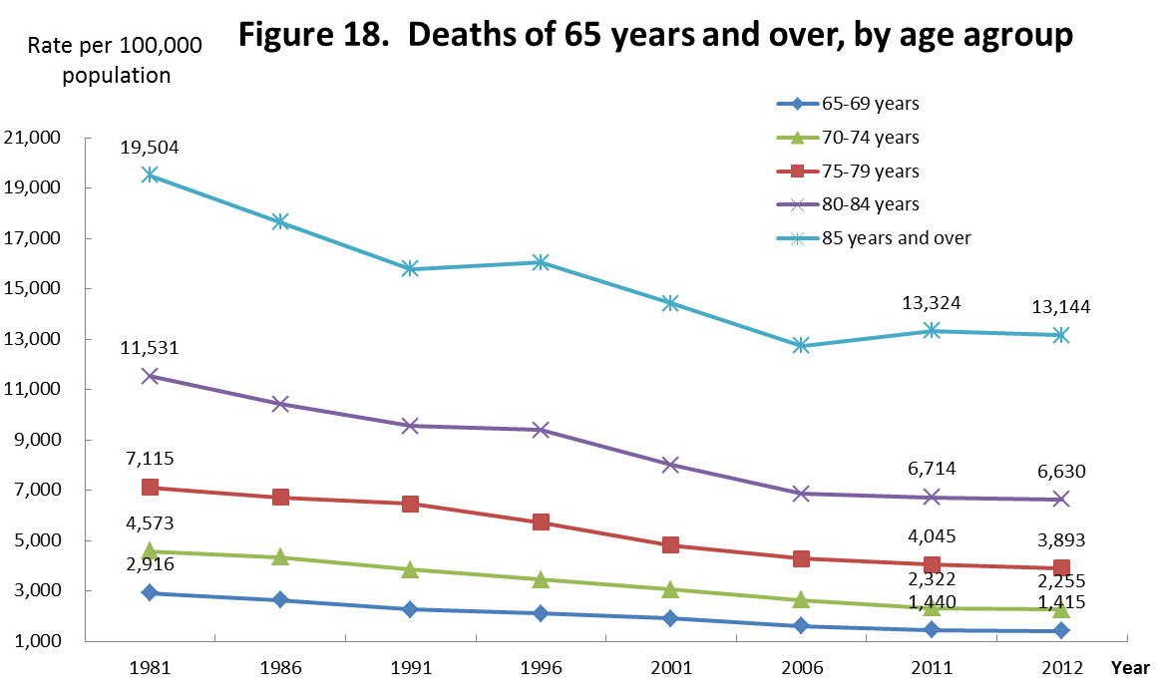
There were 105,907 deaths aged 65 and over in 2012, giving a crude rate of 4,130.2 per 100,000 population. The death rate decreased by 1.6% compared the rate of 2001.
The 10 leading causes of death for those aged 65 and over were responsible for 78.2% of total deaths. The causes and its percent of total deaths were as follows:
(1) Malignant neoplasms--24.5%
(2) Diseases of heart (except hypertensive diseases)--12.4%
(3) Cerebrovascular diseases--8.3%
(4) Pneumonia--7.9%
(5) Diabetes mellitus--6.9%
(6) Chronic lower respiratory diseases--5.6%
(7) Hypertensive diseases--4%
(8) Nephritis, nephrotic syndrome and nephrosis--3.3%
(9) Septicemia--2.9%
(10) Accidents and adverse effects--2.5%
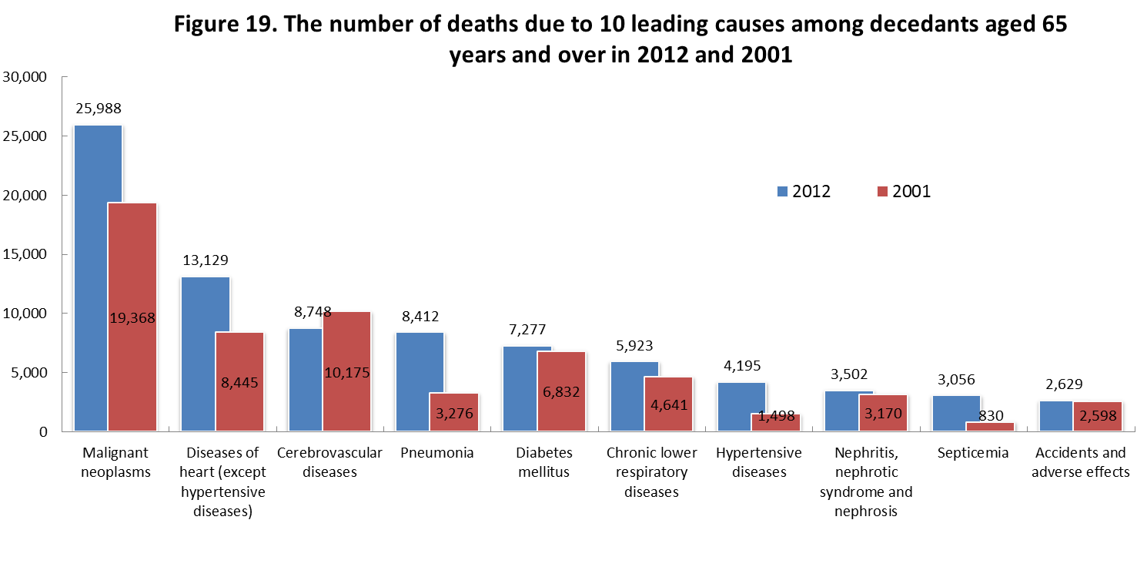
Compared with 2001, as shown in Figure 20, 5 of 10 leading cause for those aged 65 and over increased in crude death rate and percent of total deaths (shown in quadrant I) while 5 causes decreased both in crude death rate and percent of total deaths (shown in quadrant III) and cerebrovascular diseases decreased most significantly.
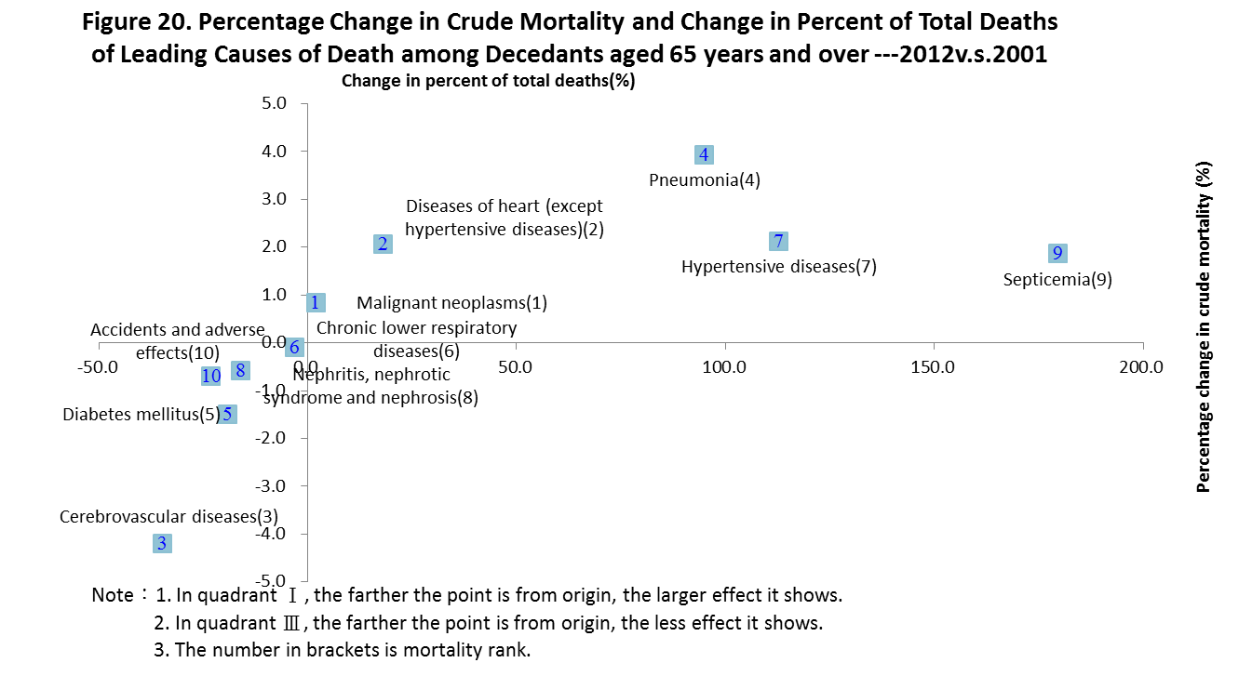
- Malignant neoplasms
- Lung and liver cancer were still the 2 leading causes of cancer death in 2012.
The number of deaths caused by cancer(malignant neoplasms) was 43,665, accounting for 28.4% of total deaths, giving a 131.3 deaths per 100,000 standard population, which was 0.7% lower than the rate of 2011 and 8.2% lower than the rate of 2001.
Malignant neoplasms has been the 1st leading cause since 1982. The standardized mortality rate for malignant neoplasms was 118.9 ⁰/₀₀₀₀ in 1986, peaking in1997 at 144.3 ⁰/_{0000 ,} starting a downtrend trend since then, and at 131.3 ⁰/₀₀₀₀ in 2012.
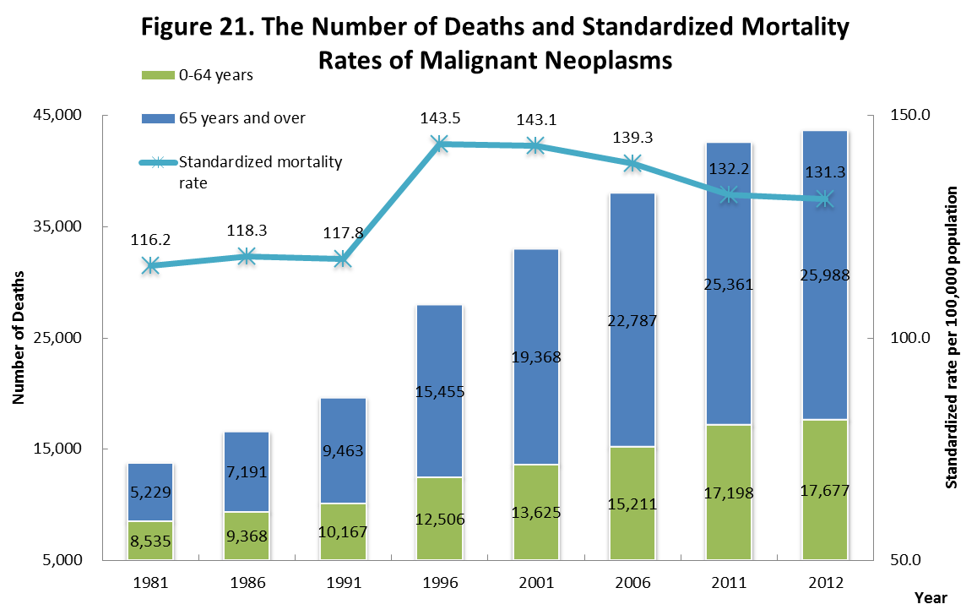
As shown in Figure 22, the percent of total deaths for malignant neoplasms increased 12.4 percent from 16.0% in 1981 to 28.4 in 2012. The percent of total deaths were consistently greater for males than females.
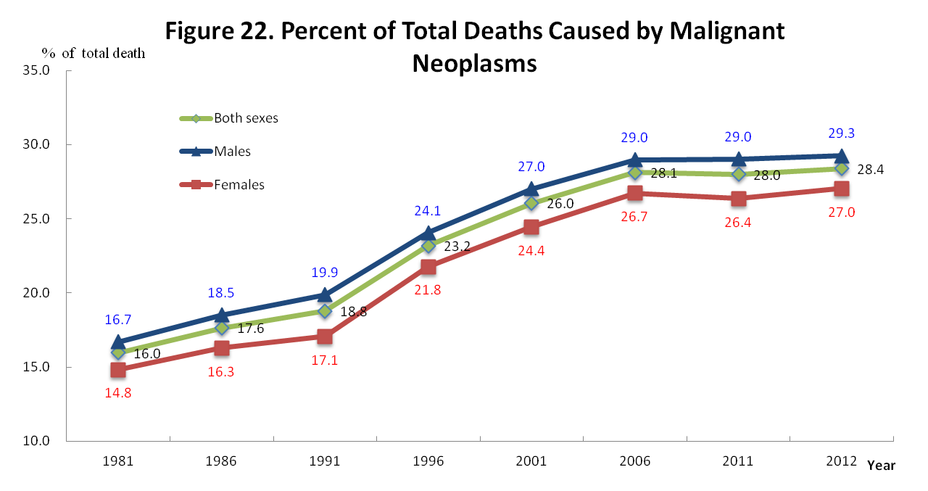
As shown in Figure 23, the ten leading causes of cancer death were sorted into rank order according to crude death rate.
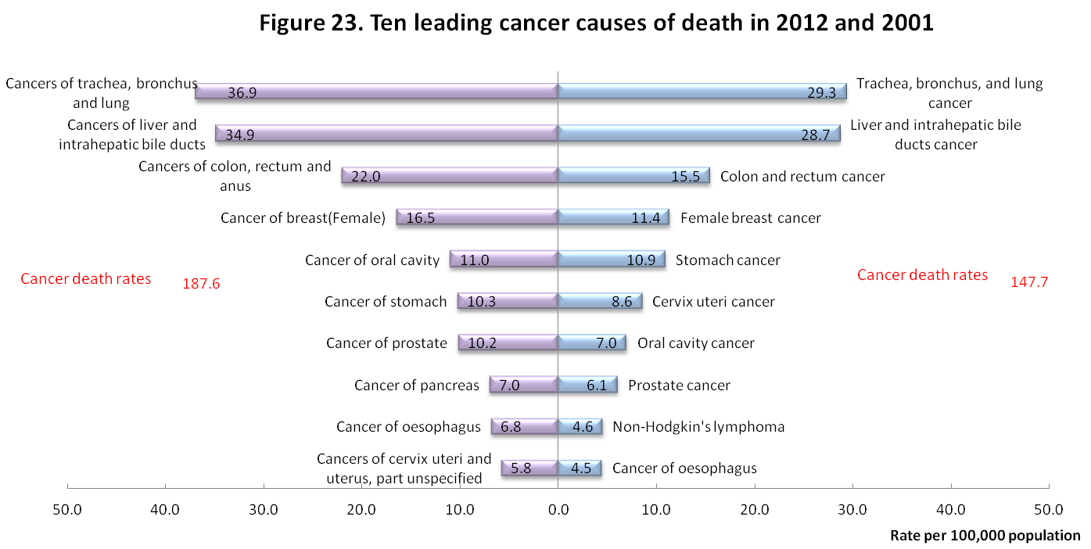
Compared with 2001, as shown in Figure 24, 5 of 10 leading cause of cancer death showed an increase in standardized death rate (shown in quadrant I and IV) and cancer of oral cavity showed a significant increase of 15.8%. 5 other causes showed a decline in standardized mortality rate. On the other hand, causes decreased in standardized death rate (shown in quadrant II and III) , especially for cancers of cervix uteri and uterus, part unspecified ( a fall of 54.6%).
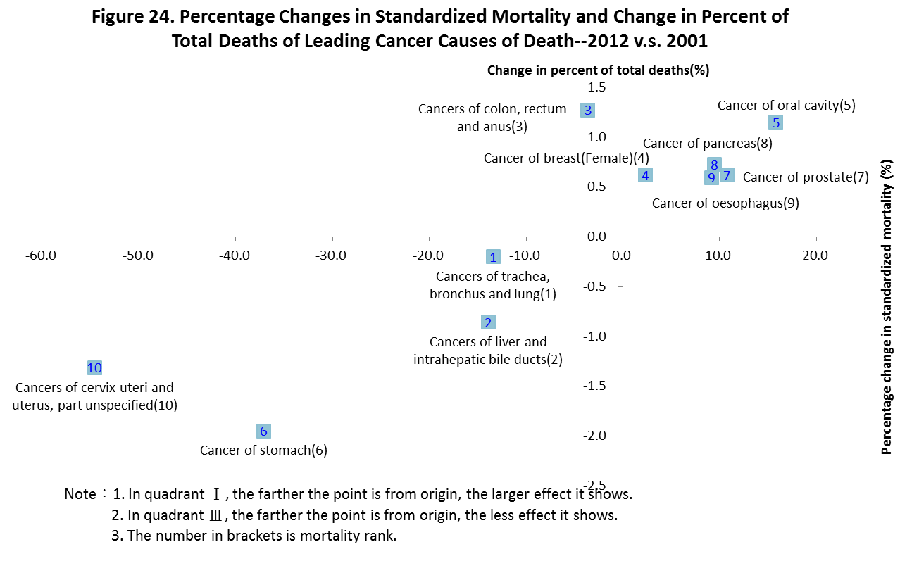
- The standardized mortality for females increased over the previous year.
There were 27,270 male decedents and 16,395 decedents due to cancer, giving a age-adjusted rate of 170.4 and 95.1 deaths per 100,000 population respectively. The male-to-female ratio for the age-adjusted rate was 1.8. The rate for males decreased by 3.3 deaths from 2011, and 10.0 deaths from 2001 per 100,000 population, while the rate for females increased by 1.7 deaths from 2011, and 10.0 deaths from 2001 per 100,000 population
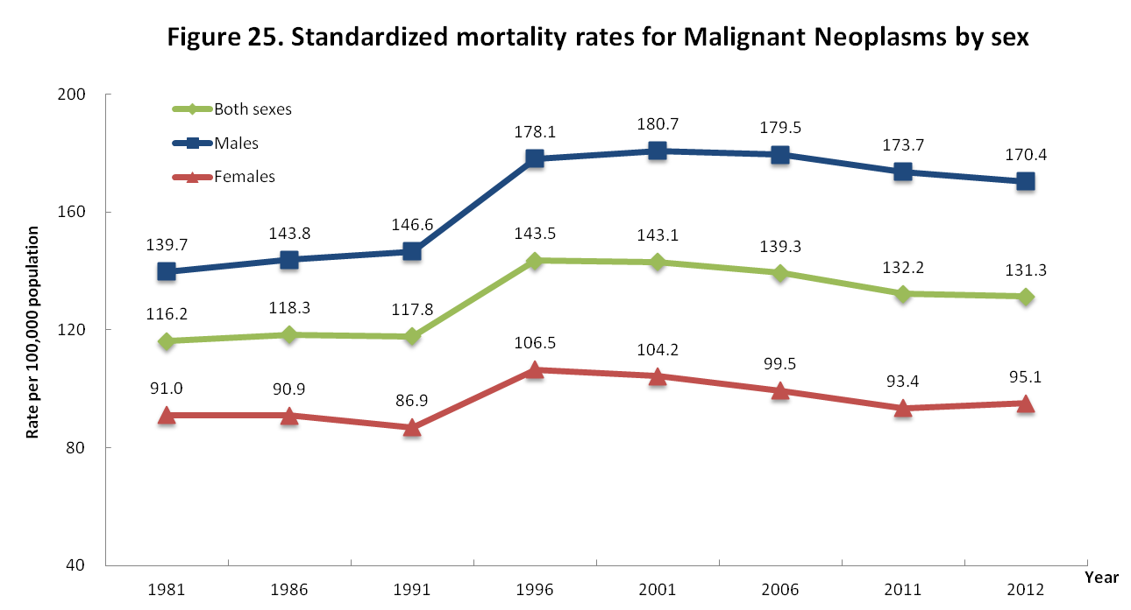
Compared the 10 leading causes of cancer death for males and females in 2012, the biggest sex difference was observed in cancer of oesophagus and cancer of oral cavity, giving a ratio of male-to-female standardized rate at 14.1 and 11.1, while the ratio was 1.3~2.2 for other causes.
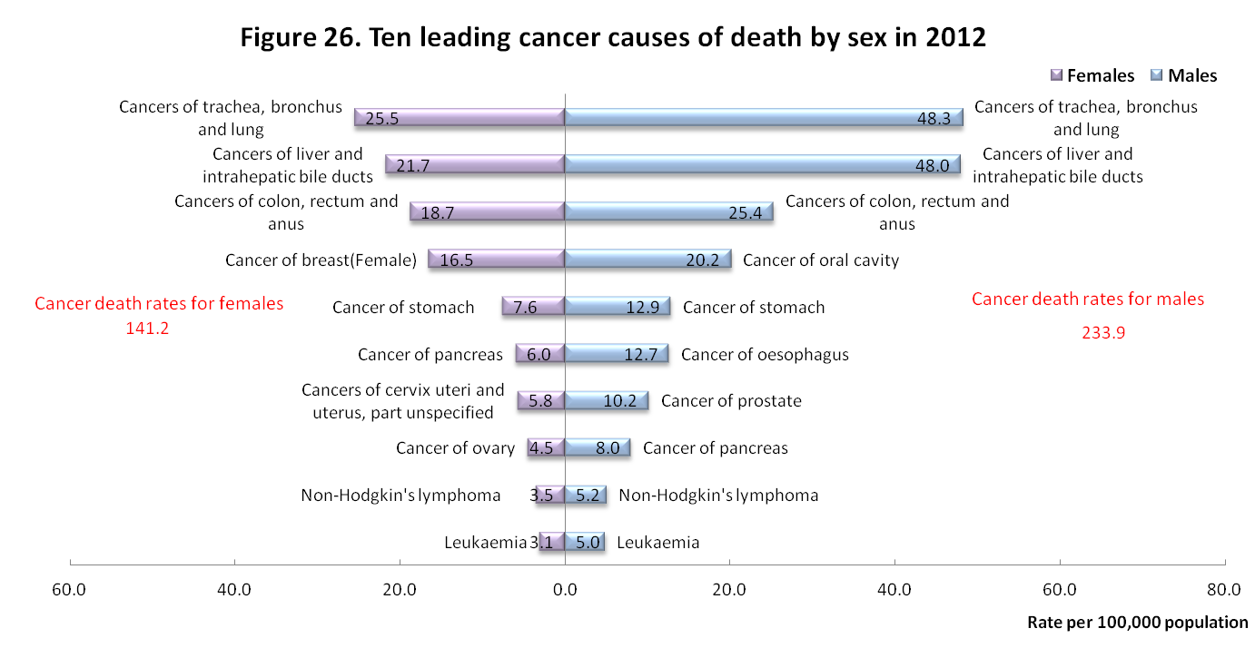
- The median age at death improved for most cancer causes between 2001 and 2012.
The average age at cancer death was 67.7 years in 2012, a 2.5 year higher than the 2001 age. The median age at cancer death was 70.0 years in 2012, giving a 2-year increase from 2001. Over the same period, median age for men increased 1 year and 2 years for women.
Shown as Table 2, 5 out of 10 causes of cancer deaths had higher median age at death than overall 70-year median age, and it’s worth noting cancer of breast(female), cancer of oral cavity, cancer of oesophagus had a relative low median age at death lower than 60 years.
Compared with 2001, most cancers experienced a improvement in median age at death, except cancer of oesophagus, cancers of cervix uteri and uterus, part unspecified and cancer of pancreas.
- The decrease in standardized mortality rate was more significant for females than males.
The standardize mortality rate for cancer was 131.3 per 100,000 population, giving a 11.8 or 8.2% decrease, while the rate for males decreased 5.7% and females decreased 8.7%.
Compared with 2001, the decline in standardized mortality were significant for cancers of cervix uteri and uterus (a 52.6% fall) and cancer of stomach(a 34.7% fall). Lung and bile cancer were 2 leading cancer cause but showed a decline in standardized mortality of 10.4% and 11.6% respectively. It’s worth noting that the rate for cancer of oral cavity increased 20.7% throughout 2001 to 2012.
- The death rate for accidents and adverse effects has shown a consistent downward trend.
There were 6,873 deaths for accidents and adverse effects in 2012, giving a 23.8 deaths per 100,000 standard population. Compared with 2001, the number of deaths decreased 2,640 deaths while age-standardized rate decreased 17.7 deaths per 100,000 standard population.
In long term, the death rate for accidents and adverse effects has shown a consistent downward trend except 921 earthquake in 1999 and Typhoon Morakot in 2009. The standardized death rate declined 67.8% from 73.9 deaths in 1981 to 23.8 deaths per 100,000 population in 2012.
Compared with 2001, the percent of total accident deaths by detail groupings in 2012 in creased for accidental poisoning and accidental falls by 4.4% and 0.5% respectively, but decreased for accidental drowning and transport accidents by 3.0% and 0.3%.
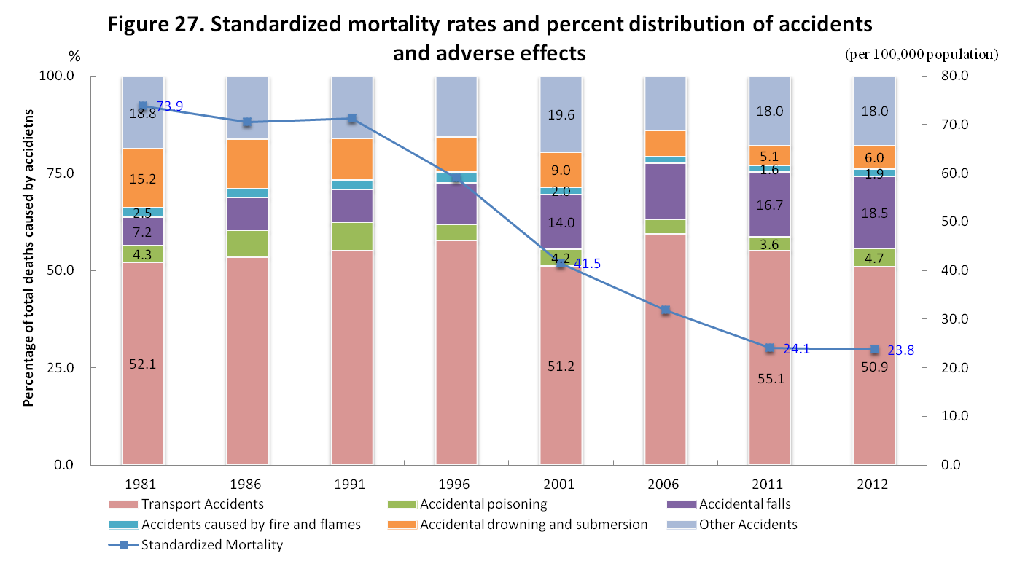
- Intentional self-harm (suicide)
- The number of deaths for intentional self-harm increased for females but decreased for males throughout 2001-2012 period.
There were 3,766 deaths for intentional self-harm in 2012, giving a ranking of 11th. The age-adjusted rate was 13.1 per 100,000 population, 11.8% higher than the rate of 2001.
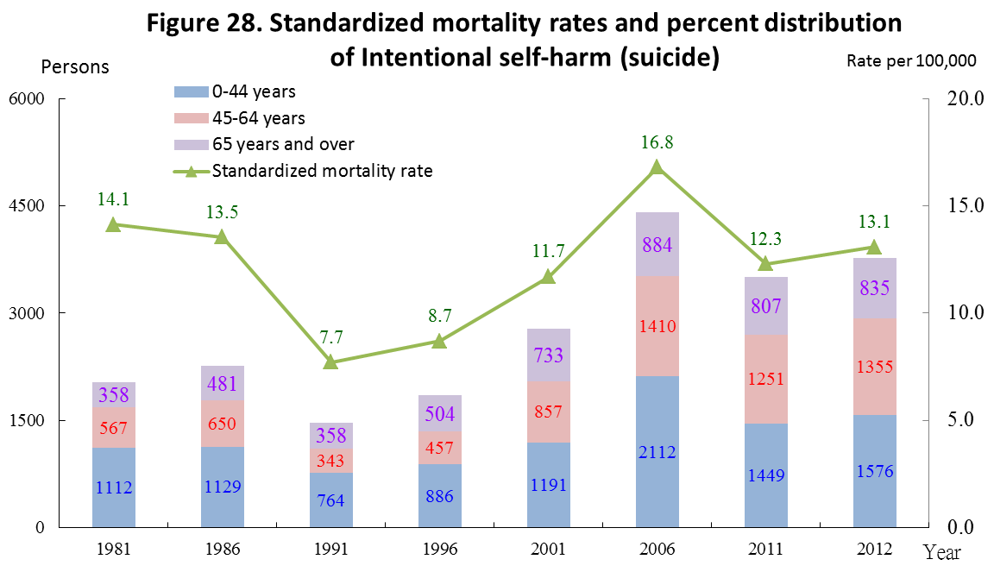
- The standardized death rates of suicide were consistently greater for males than females
Intentional self-harm caused 3,766 deaths in 2012, of which 65% were males and 35% were females, and ranked 10th and 12th for males and females respectively. The male-to-female ratio of crude death rate was 1.8.
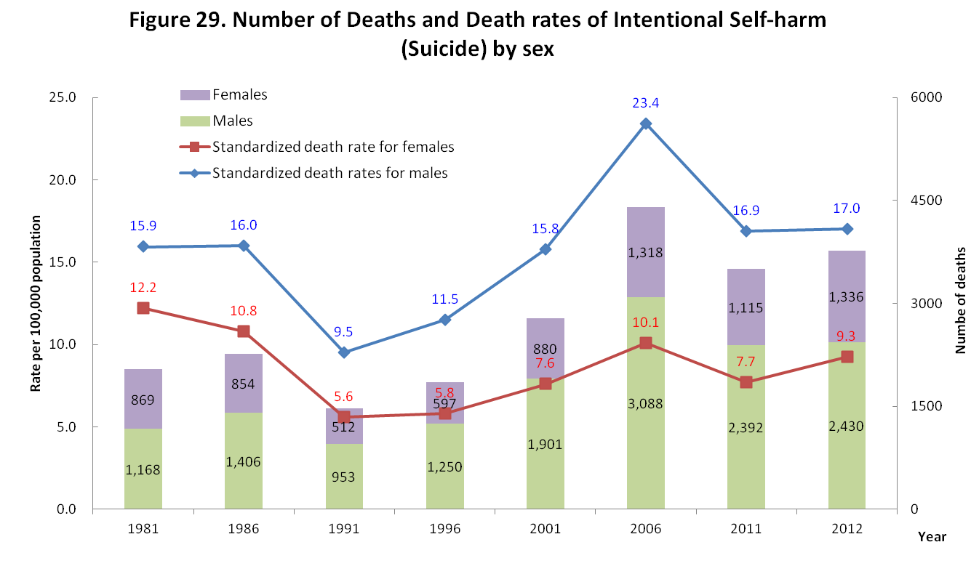
The standardized mortality was 17.0 deaths per 100,000 population for males, and 9.3 deaths for females. Both the rate for males and females increased compared with the rate of 2001, and rate for females increased more than rate for males.
- The death rate of suicide was on a rise with age
Over the past few decades, death rates of suicide rose with age. Among age-specific death rates of suicide, the highest was of persons aged over 65 years for 32.6 deaths per 100,000, followed by those aged 45-64 years for 20.6 deaths per 100,000, and persons aged 25-44 years for 18.4 deaths per 100,000.
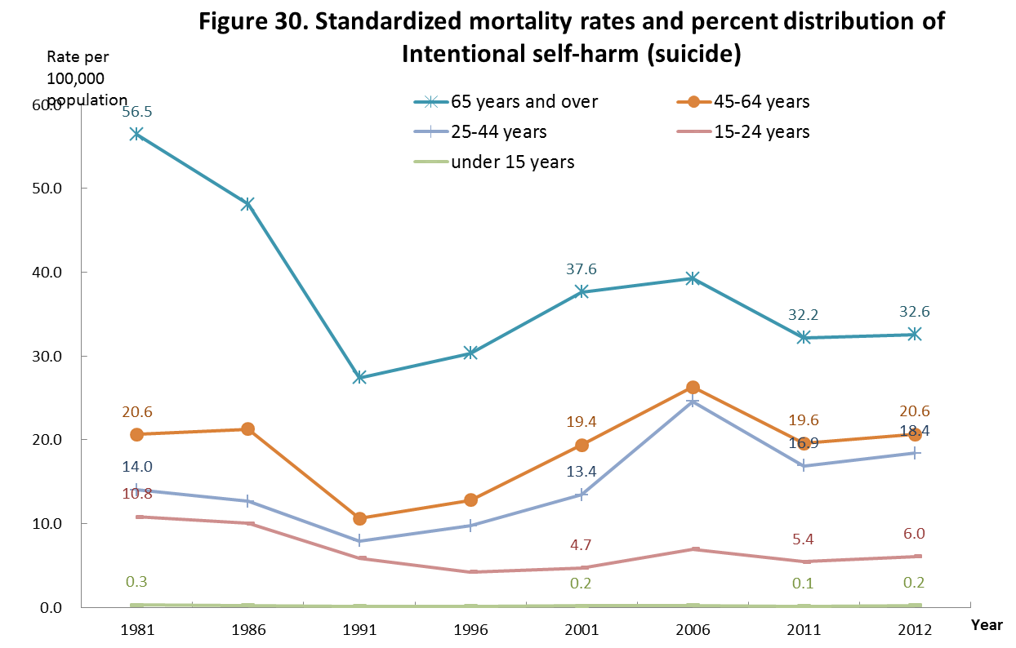
Compared with 2001, the death rate increased for age group 65 and over increased, while the death rate remained or decreased for other age groups.
- Potential years of life lost
- Average potential years of life was 17.5 years in 2012, a 2.3-year fall from 2001.
The potential years of life lost under age 70 (PYLL, see: Table 4’s note 1) was 1,021,012 person-years, 10.2% lower than the PYLL of 2001, and the average years of life lost (AYLL, see: Table 4’s note 2) was 17.5 years, with a decline of 2.3 years compared with the value of 2001.
The PYLL for males was 710,109 person-years and for females was 310,903 persons years, while the AYLL was 17.7(a fall of 2.3 years from 2001) and 17.1(a fall of 2.2 years from 2001) years respectively.
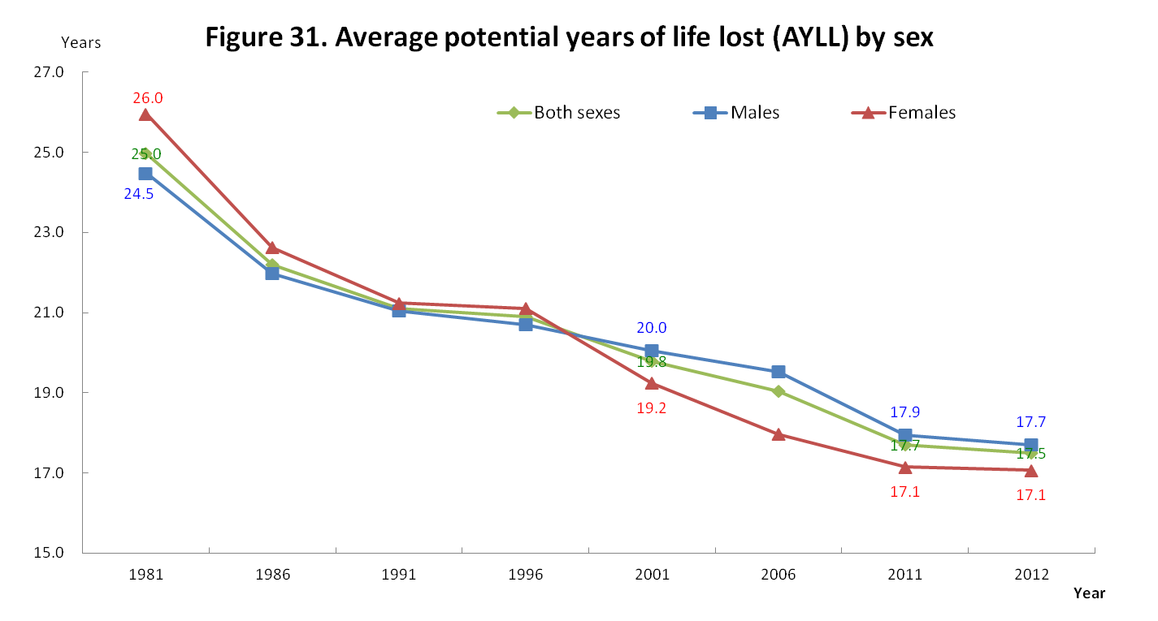
- Accidents and adverse effects, chronic liver disease and cirrhosis and diseases of heart had the highest value for AYLL.
The AYLL for 10 leading causes were as follow:
(1) Malignant neoplasms--14.4 years
(2) Diseases of heart (except hypertensive diseases)--15 years
(3) Cerebrovascular diseases--13.8 years
(4) Pneumonia--13.6 years
(5) Diabetes mellitus--11.4 years
(6) Accidents and adverse effects--26.4 years
(7) Chronic lower respiratory diseases--10.6 years
(8) Hypertensive diseases--12.5 years
(9) Chronic liver disease and cirrhosis--18.7 years
(10) Nephritis, nephrotic syndrome and nephrosis--11.9 years
Compared with 2001, accidents and adverse effects, pneumonia, malignant neoplasms, chronic lower respiratory diseases, nephritis, nephrotic syndrome and nephrosis, and chronic liver disease and cirrhosis declined in AYLL (shown in Table 4).
- Malignant neoplasms had a AYLL at 14.4 years, which was 1.0 year lower than 2001.
The total PYLL for malignant neoplasm was 313,980 person-years, 14.6 % higher than the value of 2001, and the AYLL was 14.4 years, with a decline of 1.0 year compared with the value of 2001.
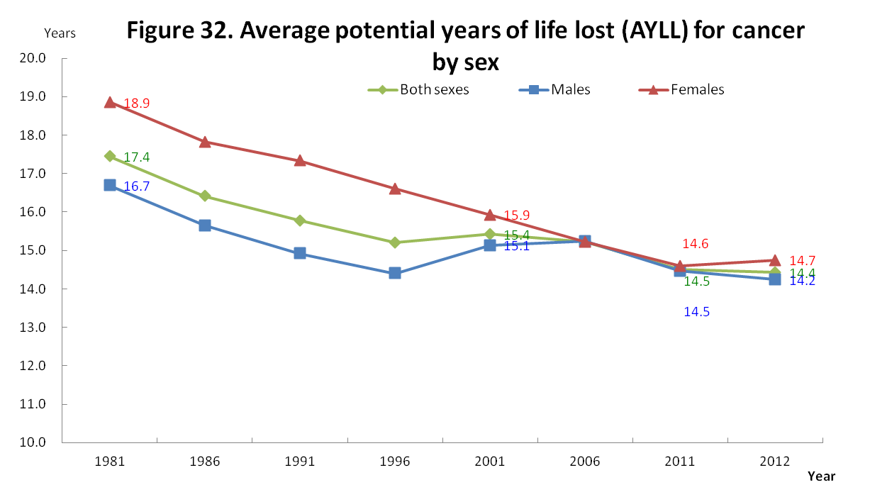
The AYLL for the 10 leading causes of cancer death were as follows:
(1) Cancers of trachea, bronchus and lung--11.8 years
(2) Cancers of liver and intrahepatic bile ducts--13.1 years
(3) Cancers of colon, rectum and anus--13.7 years
(4) Cancer of breast(Female)--16.2 years
(5) Cancer of oral cavity--16.7 years
(6) Cancer of stomach--14.1 years
(7) Cancer of prostate--6.8 years
(8) Cancer of pancreas--11.9 years
(9) Cancer of oesophagus--15.3 years
(10) Cancers of cervix uteri and uterus, part unspecified--15.9 years
Compared with 2001, cancer of trachea, bronchus and lung, cancer of pancreas and cancer of oesophagus had a higer value of AYLL, while other had a lower value of AYLL.
- AYLL was 26.4 years for accidents and adverse effects and 25.7 years for intentional self-harm (suicide).
Accidents and adverse effects had a AYLL at 26.4 years, and 27.0 for males and 24.6 years for females. Compared with the value in 2001, a fall of 4.7, 4.1 and 6.5 years for both sexes, males and females separately was observed in 2012. For the detail grouping of accidents and adverse effect as shown in Table 6, accidental drowning and submersion had the highest value of AYLL at 29.5 while accidental falls had lowest value at 19.9 years. Compared with 2001, the AYLL decreased for all groupings of accidents and adverse effects, and accidents caused by fire and flames decreased the most by 9.5 years.
The AYLL for intentional self-harm (suicide) was 25.7 years, 25.2 years for males and 26.5 for females. Compared with 2001, the AYLL decreased by 0.6 year, and by 0.9 year and 0.1 year for males and female respectively.

